**Project Design Phase-II**

**Data Flow Diagram & User Stories**

|  |  |
| --- | --- |
| Date | 16 October 2022 |
| Team ID | PNT2022TMID35083 |
| Project Name | IoT Based Safety Gadget for Child Safety Monitoring and Notification |
| Maximum Marks | 4 Marks |

**Data Flow Diagrams:**

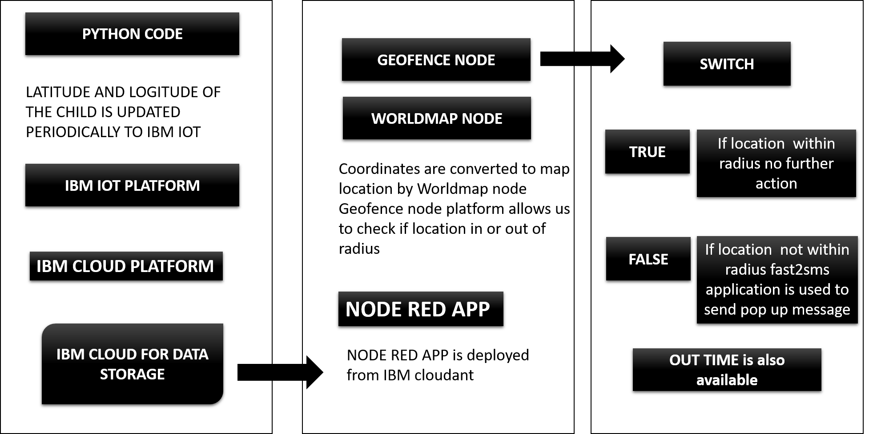

|  |  |  |  |  |  |  |
| --- | --- | --- | --- | --- | --- | --- |
| **User Type** | **Functional**  **Requirement**  **(Epic)** | **User Story**  **Number** | **User Story / Task** | **Acceptance criteria** | **Priority** | **Release** |
| Customer | Registration | USN-1 | I am able to get speed updates correctly | I can get speed constraints | High | Sprint-1 |
|  |  | USN-2 | As a user, I can register in the application correctly | I can perfectly get synced account details | Medium | Sprint-2 |
|  |  | USN-3 | As a user, I can increase or decrease speed based in the change in weather conditions with the help of sign boards | Increment or decrement in speed | High | Sprint-1 |
|  |  | USN-4 | As a user, I am able to go through an alternative direction when traffic is ahead | Correct updates of traffic details ahead of time | Medium | Sprint-1 |
|  | Login | USN-5 | As a user, I can log into the application by entering email & password | I can log into the application | High | Sprint-2 |
| Customer (Web  user) | Generating data | USN-6 | As a user I am able to utilize the web app to get information regarding child location | I can access information from web app | High | Sprint-1 |
| Customer Care  Executive | Problem solving | USN-7 | As an executive I am able to solve the problems of the users with the given instructions | Easy maintenance and problem solving | Medium | Sprint-2 |
| Administrator | Administering the  timely data | USN-8 | As an admin I am able to get through the interface and administer the data functionality | Easy administration when data is timely updated | High | Spirint-2 |